FACULTY PROFILE FOR WEBSITE
Name | : | MANISHA R | 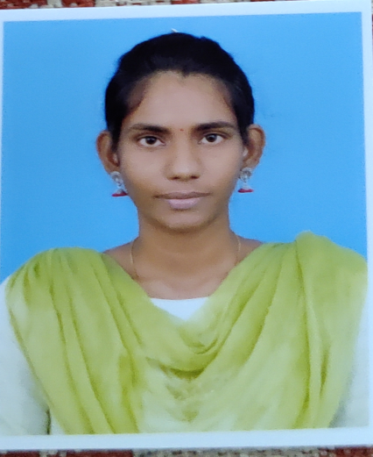
Designation | : | Assistant professor
Department | : | CSA
Educational Qualification | : | BSc (CS)., MCA
Subject Interest | : | C, HTML & CSS, PHP, SOFTWARE ENGINEERING
Contact Address | : | R.MANISHA  Department of Computer Science and Applications  Periyar Maniammai Institute of Science and Technology  Periyar Nagar, Vallam , Thanjavur  E Mail – manishar@pmu.edu  Phone No : +91 8754321049
Funded Projects | : | -
Patents | : | -
Workshop  attended |  | - Participated in one day workshop on “Python Programming” held on 23rd January 2019 at Periyar Maniammai Institute of Science and Technology, Vallam, Thanjavur.  - Participated in one day workshop on “R Programming” Organised by Periyar Maniammai Institute of Science and Technology, Vallam, Thanjavur.  - Got Certified on “Web Designing” at Sengamala Thayaar Educational Trust Women’s College, Mannargudi.  - Got Certified on “Internet Of Things” Organised by Periyar Maniammai Institute of Science and Technology, Vallam, Thanjavur.  - Participated in one day webinar on “Big Data” Organised by Periyar Maniammai Institute of Science and Technology, Vallam, Thanjavur.  - Participated in one day webinar on “Block Chain Technology” Organised by Periyar Maniammai Institute of Science and Technology, Vallam, Thanjavur.  - Got Certified on “PHP” at Infosystem, Thanjavur.
National Seminar |  | - Participated Three-day National Seminar on “Awareness and Services Provisions for Persons With Multiple Disabilities for requiring Early Rehabilitation in Tamil” held from 3rd to 5th December 2019 at Periyar Maniammai Institute of Science and Technology, Vallam, Thanjavur.

